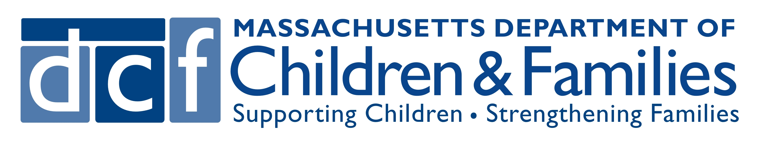
Report of Child(ren) Alleged to be Suffering from
Serious Physical or Emotional Injury by Abuse or Neglect

Massachusetts law requires mandated reporters to immediately make a report to the Department of Children and Families (DCF) when they have reasonable cause to believe that a child under the age of 18 years is suffering from abuse and/or neglect by:

STEP 1: Immediately reporting by oral communication to the local DCF Area Office (see contact information at end of form); and
STEP 2: Completing and sending this written report to the local DCF Area Office
within 48 hours of making the oral report.
For more information about requirements for mandated reporters and filing a report of alleged abuse and/or neglect
please see A Guide for Mandated Reporters available on the DCF website at www.mass.gov/dcf.


Please complete all sections of this form. If some data is uncertain or unknown, please signify by placing a question mark (“?”) after the entry.

- Children Reported
Name Current Location / Address Sex Age or Date of Birth
❑ Male ❑ Female

❑ Male ❑ Female

❑ Male ❑ Female

❑ Male ❑ Female

❑ Male ❑ Female

- Parent or Guardian 1
Name
First Last Middle
Address
Street & Number City / Town State Zip Code

Phone # Age/Date of Birth

- Parent or Guardian 2
Name:
First Last Middle
Address:
Street & Number City / Town State Zip Code
Phone #: Age/Date of Birth

- Reporter / Report
Report Date: ❑ Mandatory Report ❑ Voluntary Report
Reporter’s Name:
First Last Middle
(If the reporter represents an institution, school or facility, please indicate)

Reporter’s Address:
Street & Number City / Town State Zip Code
Phone #:
Has reporter informed caretaker of report ? ❑ Yes ❑ No

What is the nature and extent of injury, abuse, maltreatment or neglect? Please list any prior evidence of same and/or other worries regarding danger to the child(ren). (Please cite the source of this information if not observed firsthand.)

If known, please provide the name(s) and contact information of the person(s) responsible for the injury, abuse, maltreatment or neglect and/or any other information that you think might be helpful in establishing the cause of the injury, abuse, maltreatment or neglect:

What are the circumstances under which the reporter became aware of the injury, abuse, maltreatment or neglect? Please include information on dates and timeframes for when the injury, abuse, maltreatment or neglect occurred:

What action has been taken thus far to treat, shelter or otherwise assist the child(ren) to deal with the situation?

If report involved alleged domestic violence, please list any information that will help DCF make safe contact with the family (e.g., work schedule, place of employment, daily routines for the adult victim):

Please provide any information about the family’s strengths and capacities that you think will be helpful to DCF in ensuring the child’s safety
and supporting the family to address the abuse and/or neglect concerns:

Signature of Reporter: _______________________________________________________________________________________________
Northern Region
Lowell 978-275-6800
Framingham508-424-0100
Haverhill 978-469-8800
Lawrence978-557-2500
Cambridge/Somerville617-520-8700
Malden781-388-7100
Cape Ann, Salem978-825-3800
Lynn781-477-1600
Southern Region
Arlington781-641-8500
South Weymouth781-794-4400
Cape Cod & Islands508-760-0200
Plymouth508-732-6200
Fall River 508-235-9800
New Bedford 508-910-1000
Brockton508-894-3700
Taunton/Attleboro508-821-7000
Western Region
Greenfield 413-775-5000
Holyoke413-493-2600 Springfield413-452-3200
Robert Van Wart Center413-205-0500
East Springfield
Worcester, East & West508-929-2000
Whitinsville508-929-1000
Leominster978-353-3600
Pittsfield413-236-1800
Boston Region
Dimock Street, Roxbury617-989-2800
Hyde Park 617-363-5000
Harbor, Chelsea617-660-3400
Park Street, Dorchester617-822-4700
DCF AREA OFFICES

To report child abuse and/or neglect: Weekdays from 9:00 am to 5:00 pm call the local DCF Area Office.
Weekdays after 5:00 pm and 24 hours on weekends and holidays call the
Child-At-Risk-Hotline 1-800-792-5200

